PETITION TO STOP THE DEMOVICTIONS!

I am adding my name in support of the ACORN Tenant Union fighting to stop [LANDLORD NAME]’s demovictions at [BUILDING ADDRESS]. Housing is a right, not an investment! That’s why the tenant union is demanding the landlord stop all plans to demolish tenants’ homes and destroy affordable housing.

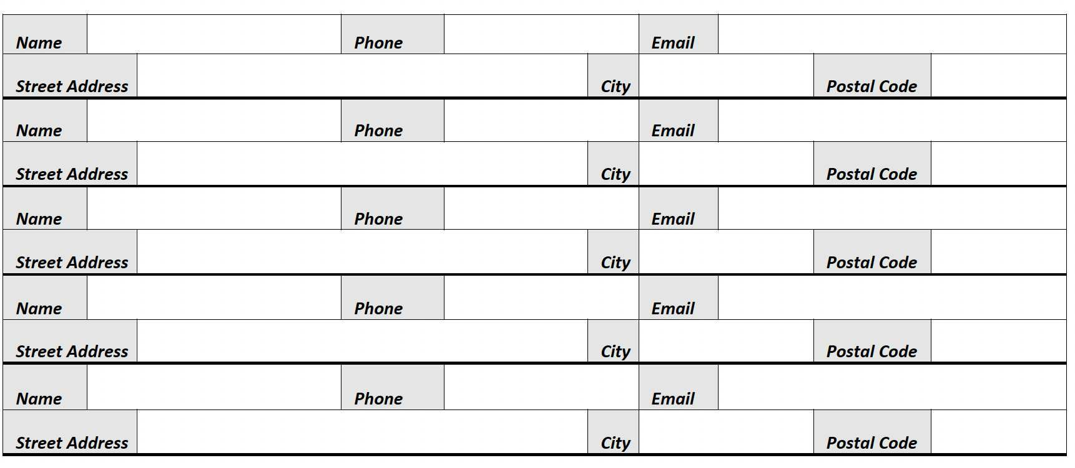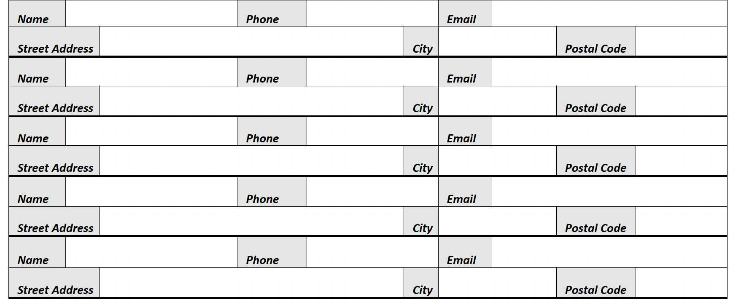

By providing my name I consent to receiving occasional emails from ACORN Canada.

**C:\Users\Not Thomas\Downloads\set-of-social-media-icon-in-round-bakground-free-vector.jpgFor More Information**: [www.acorncanada.org](http://www.acorncanada.org) @ACORNCanada