PETITION FOR HEALTHY HOMES!

I am adding my name in support of the ACORN Tenant Union [IN CITY OR AT BUILDING ADDRESS] fighting for healthy homes. I support the tenant unions’ demands for [LANDLORD NAME] to address tenants’ issues with [NAME 3 COMMON ISSUES. EXAMPLE: BROKEN ELEVATORS, COCKCROACHES & LACK OF HEAT] immediately.

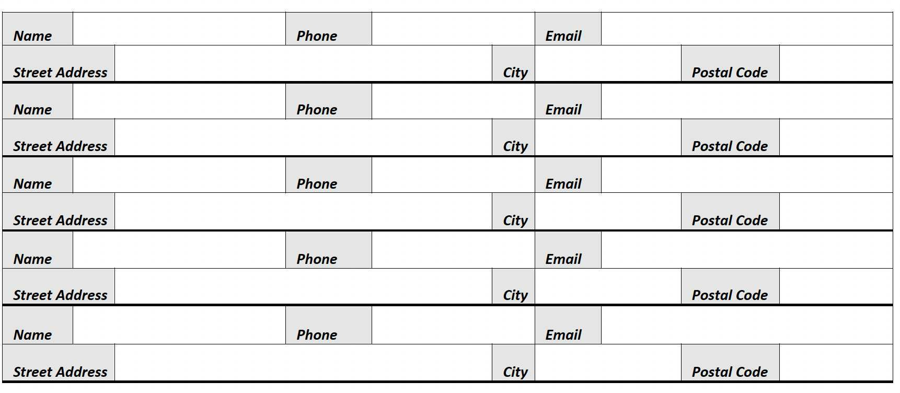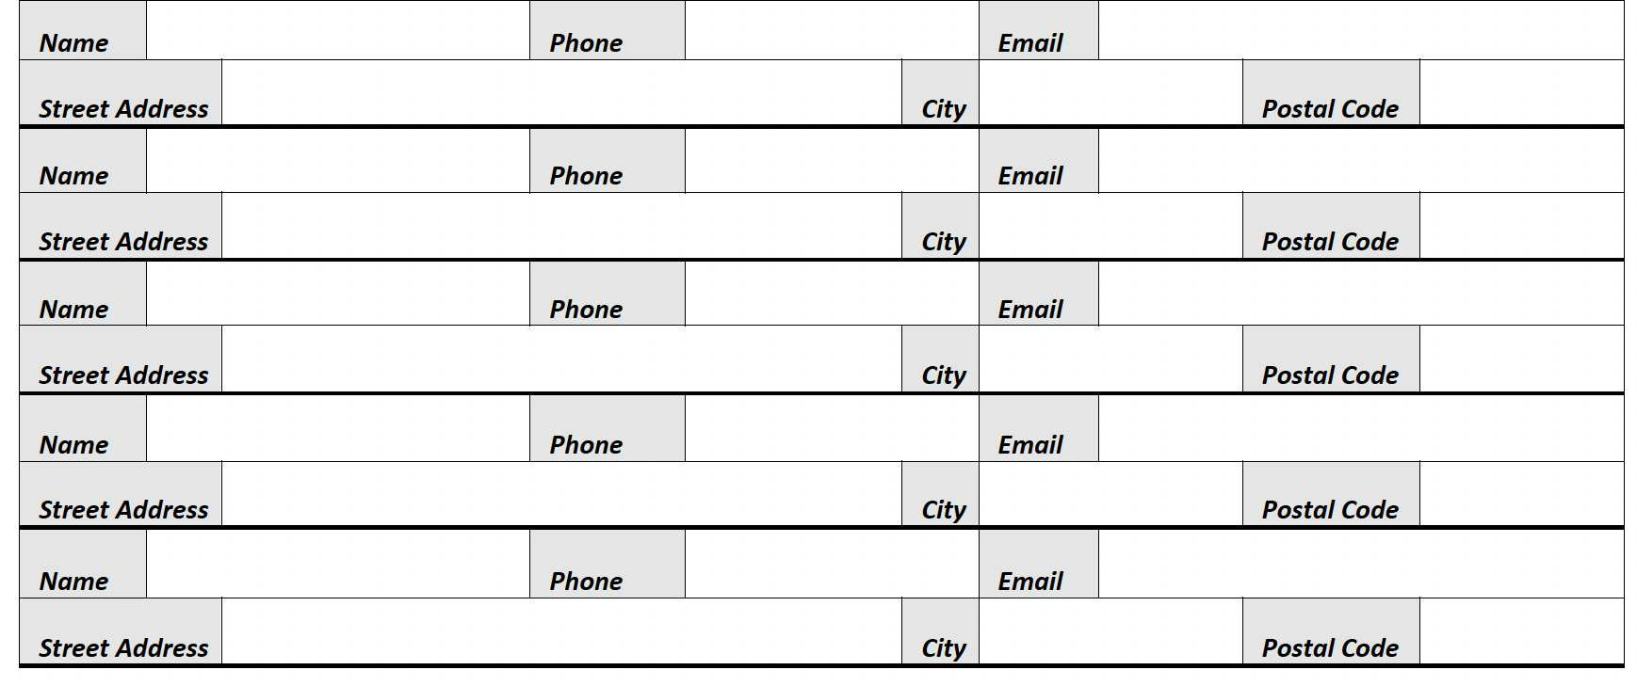

By providing my name I consent to receiving occasional emails from ACORN Canada.

**C:\Users\Not Thomas\Downloads\set-of-social-media-icon-in-round-bakground-free-vector.jpgFor More Information**: [www.acorncanada.org](http://www.acorncanada.org) @ACORNCanada