PETITION TO STOP THE RENOVICTIONS!

I am adding my name in support of the ACORN Tenant Union fighting to stop [LANDLORD NAME]’s renovictions at [BUILDING ADDRESS]. Housing is a right, not an investment! That’s why the tenant union is demanding the landlord stop all attempts to evict tenants for unnecessary renovations and allow tenants to stay in their homes.

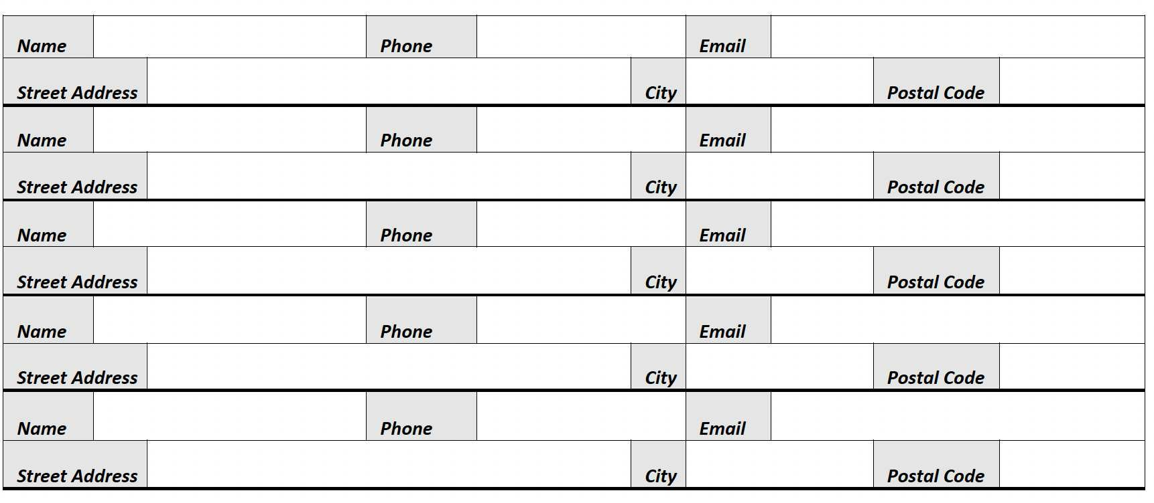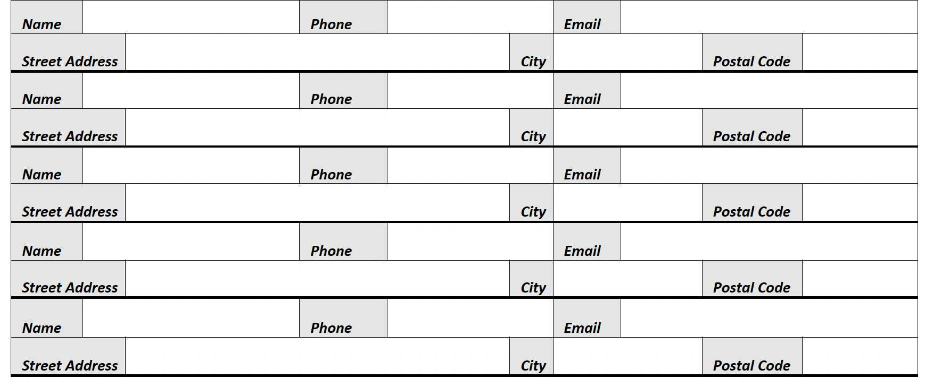

By providing my name I consent to receiving occasional emails from ACORN Canada.

**C:\Users\Not Thomas\Downloads\set-of-social-media-icon-in-round-bakground-free-vector.jpgFor More Information**: [www.acorncanada.org](http://www.acorncanada.org) @ACORNCanada