PETITION TO STOP THE RENT INCREASE!

I am adding my name in support of the ACORN Tenant Union fighting to stop [LANDLORD NAME]’s rent gouging at [BUILDING ADDRESS]. Housing is a right, not an investment! That’s why the tenant union is demanding the landlord drop the [RENT INCREASE %. EXAMPLE: 5% OR 4-6%] rent increase.

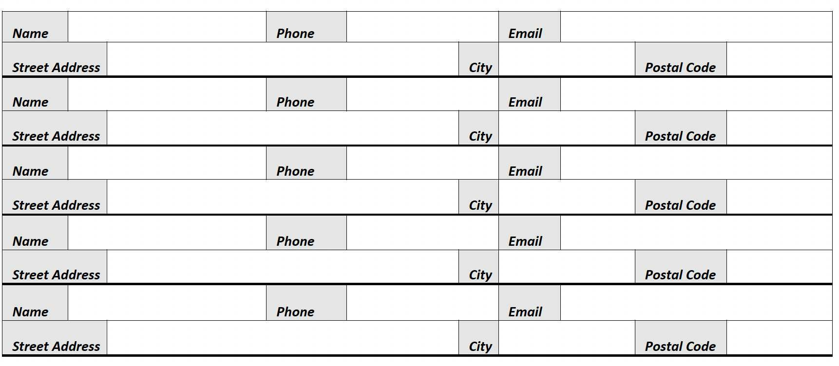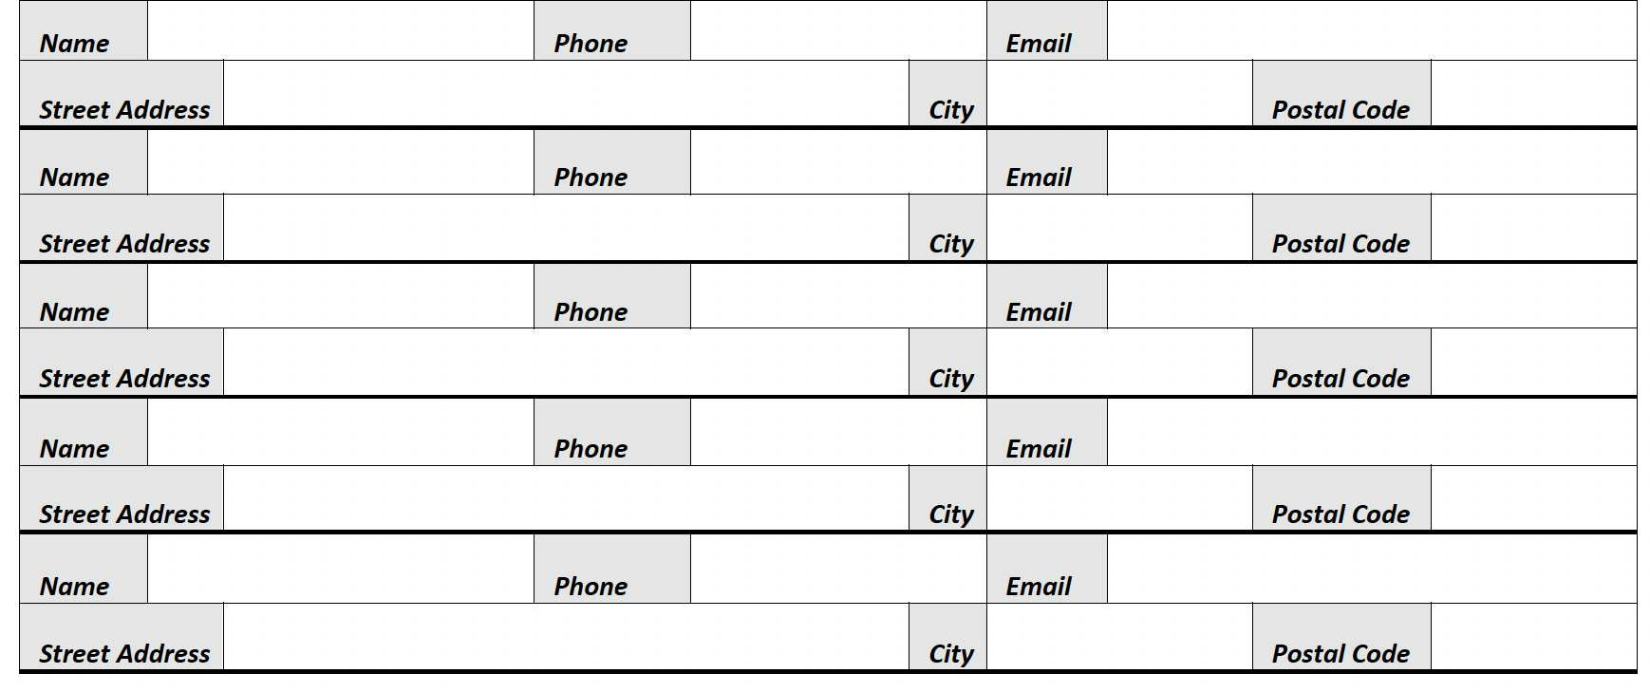

By providing my name I consent to receiving occasional emails from ACORN Canada.

**C:\Users\Not Thomas\Downloads\set-of-social-media-icon-in-round-bakground-free-vector.jpgFor More Information**: [www.acorncanada.org](http://www.acorncanada.org) @ACORNCanada