[Building Name] ACORN



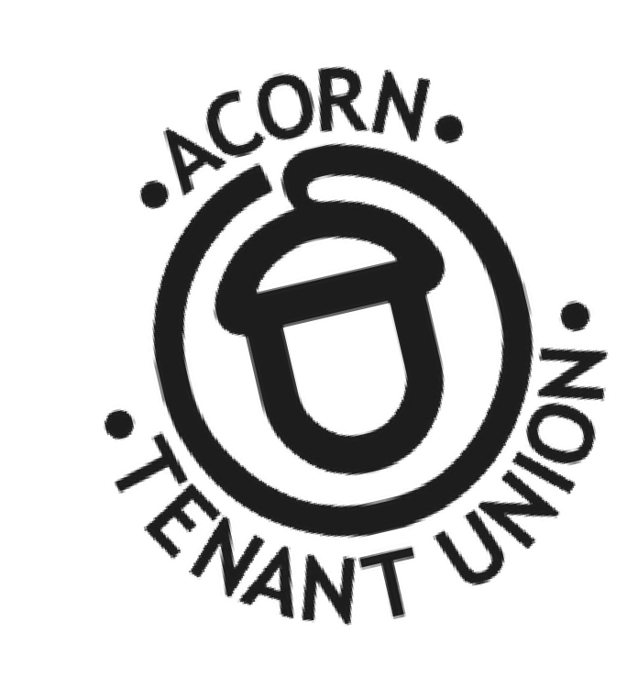BEWARE OF DEMOVICTIONS:

* Received an N13 eviction notice?
* Landlord demolishing your apartment for

condos, luxury rentals or something that is NOT

affordable housing?

* 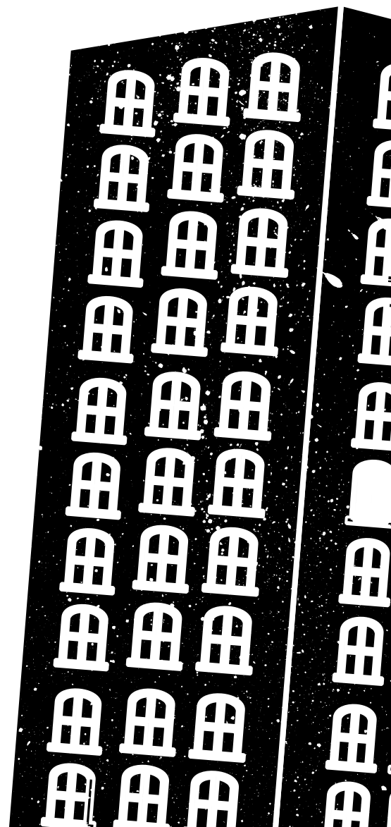Landlord applying for city permits to redevelop?

***JOIN US to organize with neighbours & fellow tenants to fight back!***

[DATE/TIME OF MEETING]

[NAME OF LOCATION/ADDRESS]

**For More Information:**

[OPTIONAL: YOUR PHONE#/EMAIL]

www.acorncanada.org

Know Your Rights:[https://getorganized.acorncanada.org/](https://getorganized.acorncanada.org/know-your-rights/)

C:\Users\Not Thomas\Downloads\set-of-social-media-icon-in-round-bakground-free-vector.jpgBecome a Member: <https://acorncanada.org/join-us/>

@ACORNCanada