City

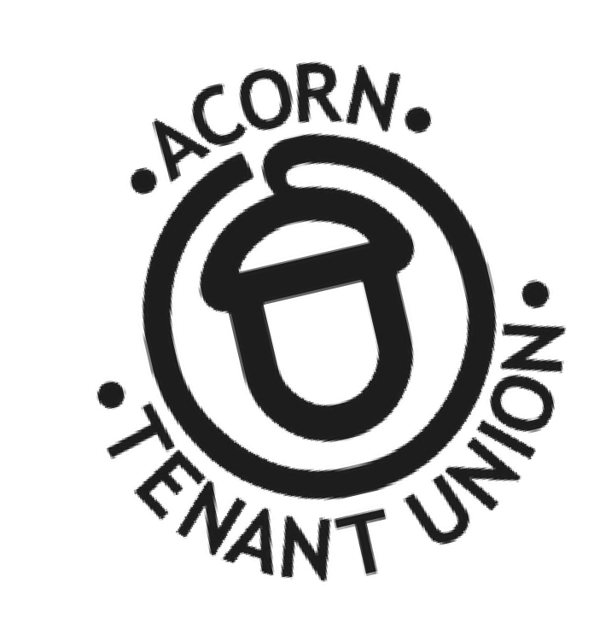Tenants



Tenants are forming an

ACORN Tenant Union in

the city!

***JOIN US to organize with fellow tenants to demand change on issues like slumlords, high rent, evictions & MORE!***

[DATE/TIME OF MEETING]

[NAME OF LOCATION/ADDRESS]

**For More Information:**

[OPTIONAL: YOUR PHONE#/EMAIL]

www.acorncanada.org

Know Your Rights:[https://getorganized.acorncanada.org/](https://getorganized.acorncanada.org/know-your-rights/)

C:\Users\Not Thomas\Downloads\set-of-social-media-icon-in-round-bakground-free-vector.jpgBecome a Member: <https://acorncanada.org/join-us/>

@ACORNCanada